Add ROI Printer

**Add ROI Printer - UTS Print Server**

**Windows Procedure:**

1. Search up “Printers & Scanners” on the Windows Taskbar
2. Click “Add Device”
3. When the option appears, click on “Add a new Device Manually”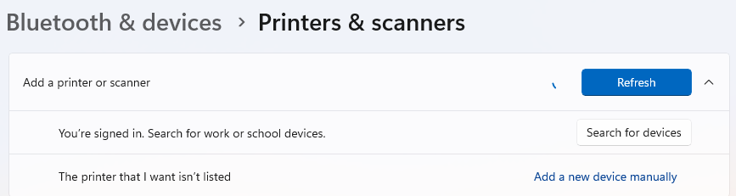
4. Add Printer > Select a shared printer by name:
5. Enter “*\\roiprint\myQueue*”

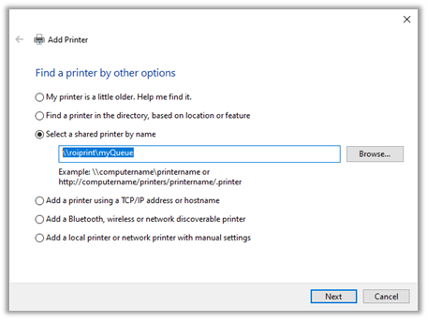

1. Click “Next”
2. Check the box if you would like this to be your default printer, then click Finish

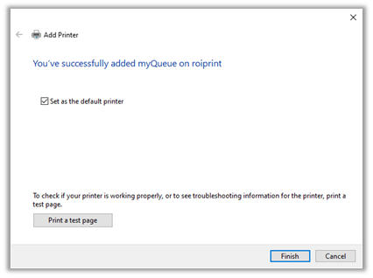

# Troubleshooting/Notes:

* Admin credentials may be required to add the printer (check on Intune)
* Ensure Network Discovery is ON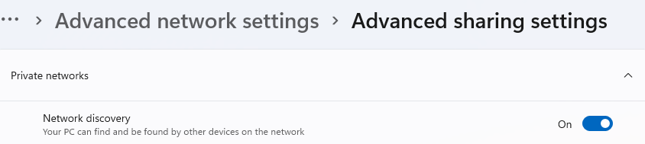
* If the user’s computer is a Mac, ensure they are doing this on Remote Access and are connected to the VPN.

## Alternate Procedure:

1. Enter “run” into the taskbar search
2. Enter “\\roiprint”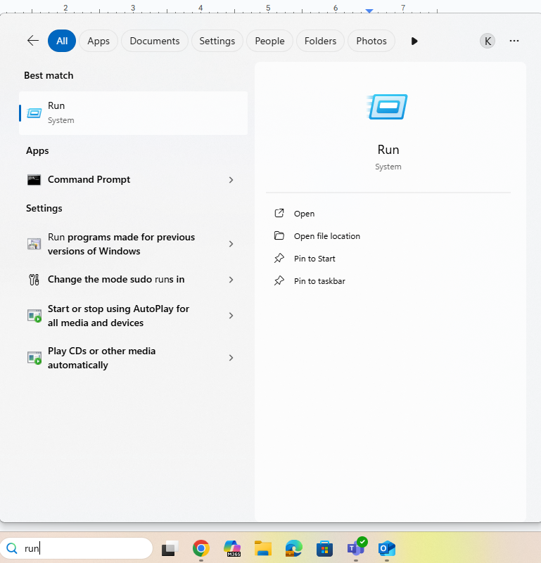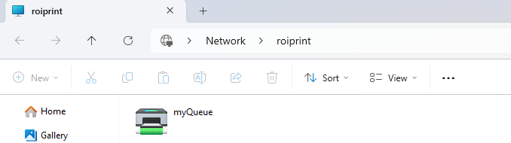
3. Click myQueue (may require credentials to continue)
4. Printer is now added, deploy a test page to see and change destination to myQueue